SIT305

Grading Criteria

Platform: [Unity]

Prefer: [on-campus]

By HONG LY (SID: 215350188)

My Email: hly@deakin.edu.au

# Marking Justification

|  |  |
| --- | --- |
| Critical Information Summary | |
| Student Name | HONG LY |
| SID | 215350188 |
| Mark Aimed For (%) | 90% |

### **Criteria: Code Commits [HD]**

☑ [Pass]

* At least 10 unique-day commits (per person).

☑ [Credit]

* At least 15 unique-day commits.

☑ [Distinction]

* At least 20 unique-day commits.

☑ [HD]

* At least 25 unique-day commits.

**Evidence:** I have commit and push source codes more than 25 unique-day. Below is the link to the changelog file.

<https://github.com/lyhd/Dragon-World/blob/master/changelog.txt>

### **Criteria: Weekly Progress (Changelog) [D]**

☑ [Pass]

* Changelog updated at least once a week (per person).

☑ [Credit]

* Changelog lists all new major features added per day-of-work, and a list of “Still working on” for current features in progress.

**Evidence:**

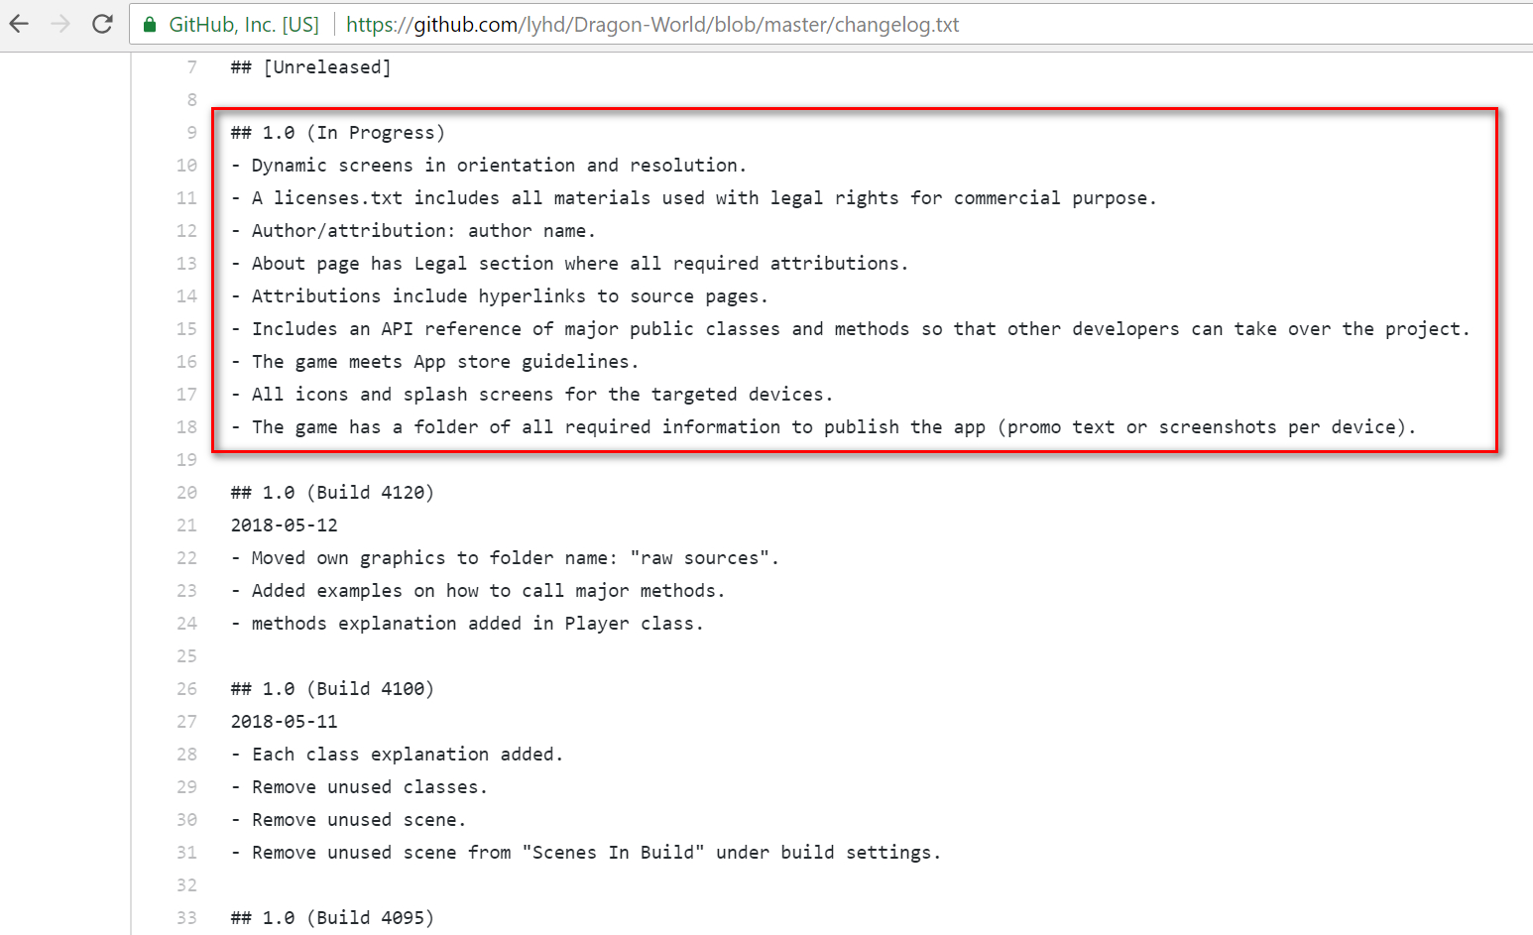

☑ [Distinction]

* Included at the end of each work day, a summary of how I am progressing related to the milestones.

**Evidence:**

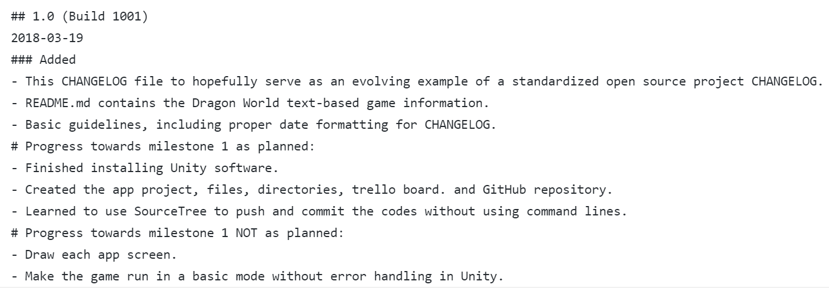

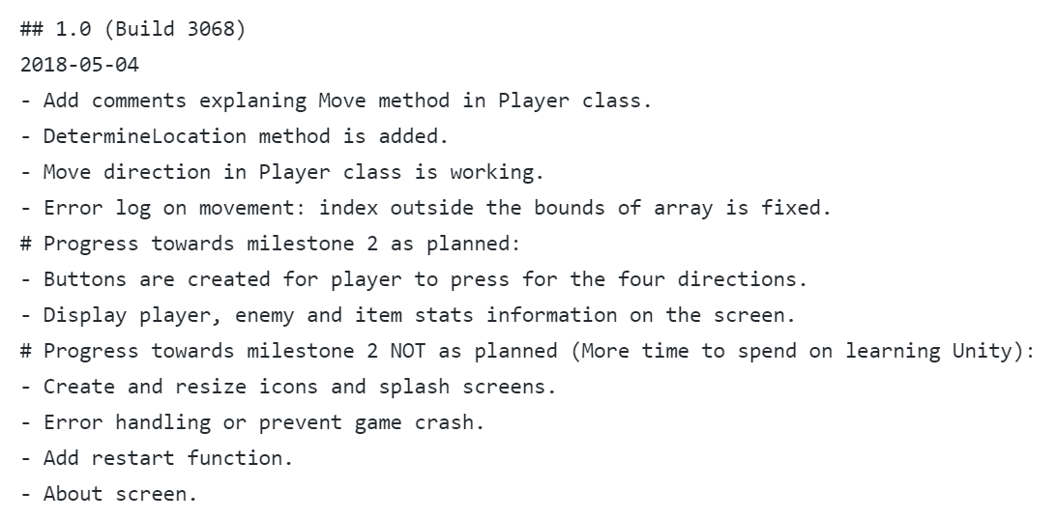

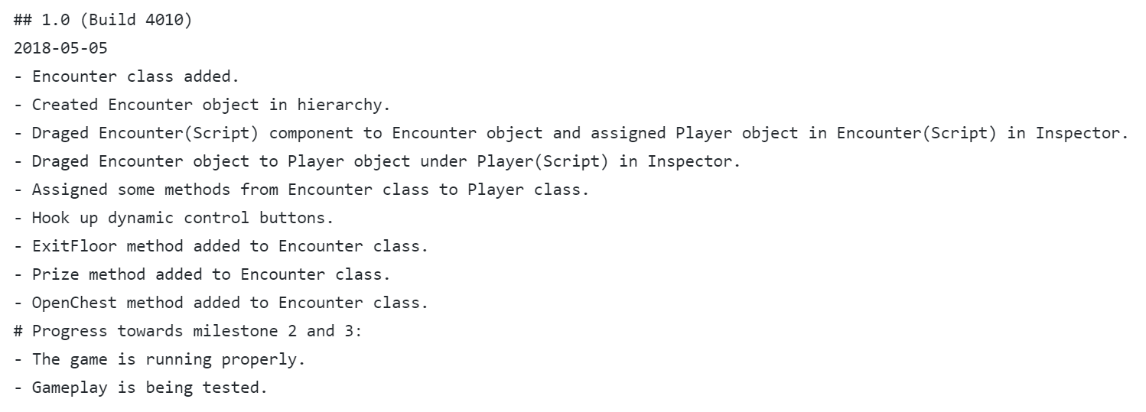

### **Criteria: Code Quality [D]**

☑ [Pass]

* Indentation is perfect. Every class, and each major method/function has a brief comment.

**Evidence:**

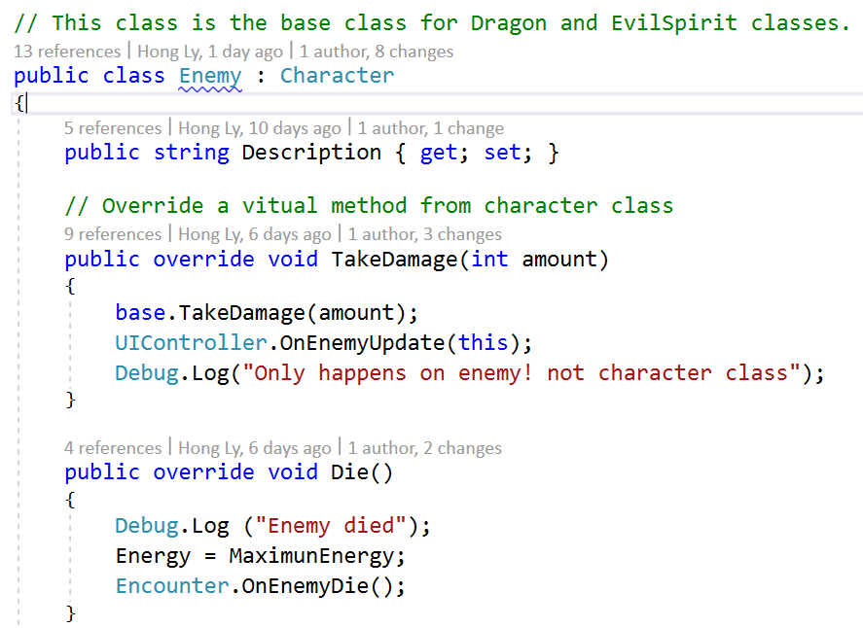

☑ [Credit]

* Every class, and each major method/function has an explanation comment, as well as method/function signature explanation.

**Evidence:**

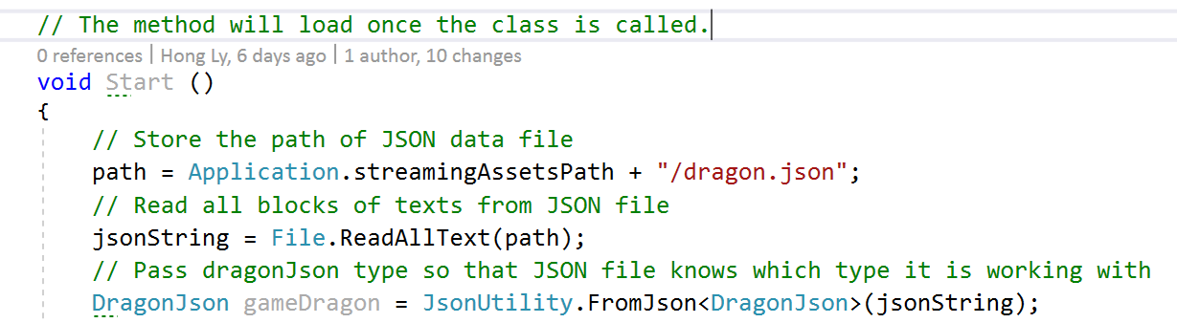

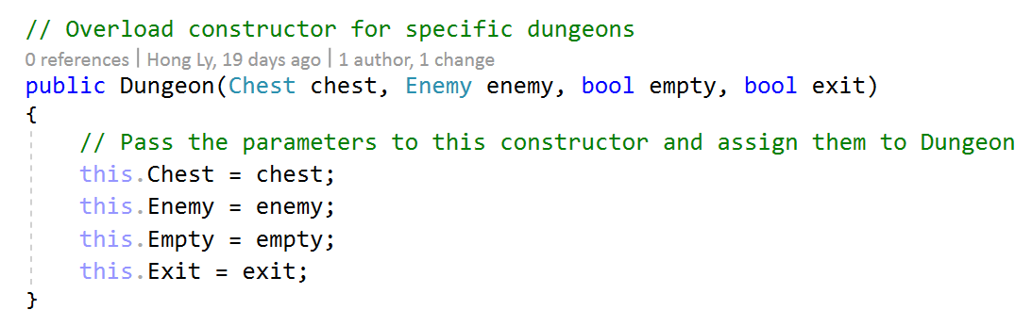

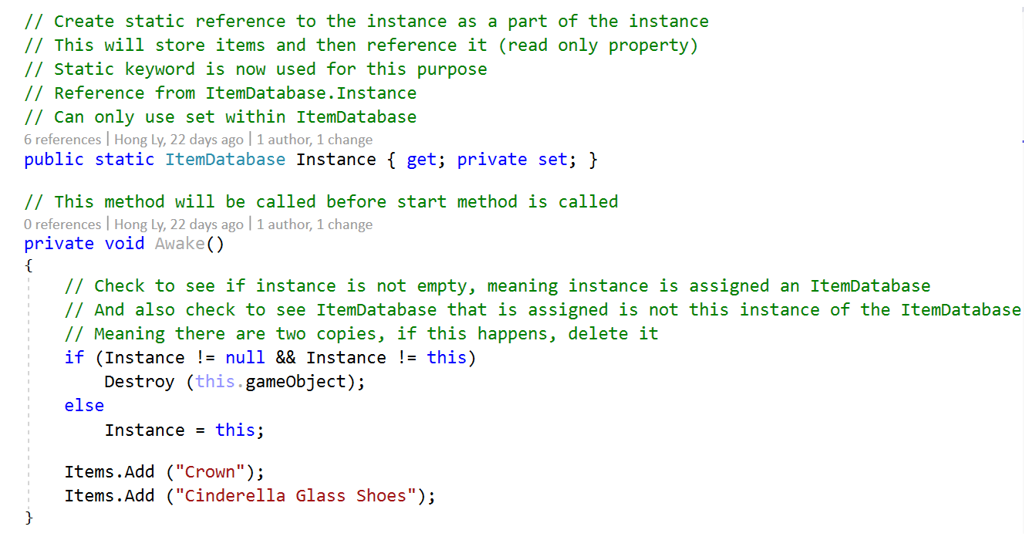

☑ [Distinction]

* Each major method has several examples of how to call it (parameters).
* Snippet examples of returned data for each method.

**Evidence:**

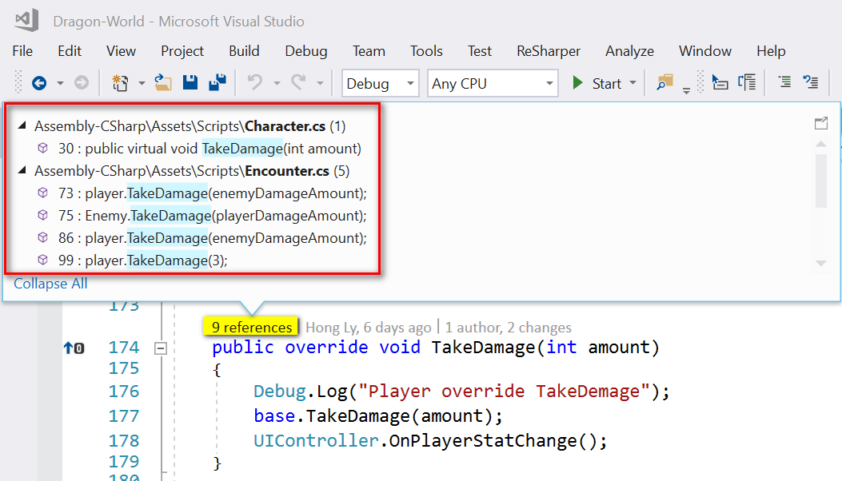

*TakeDamage method has been used 9 times as seen.*

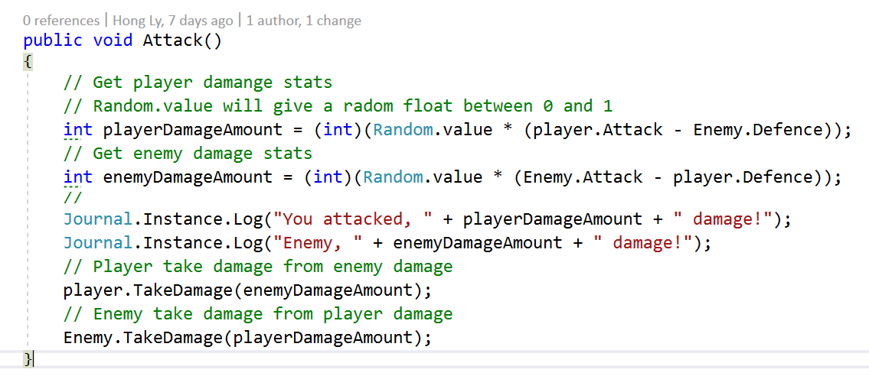

*TakeDamage method is used with different returned data.*

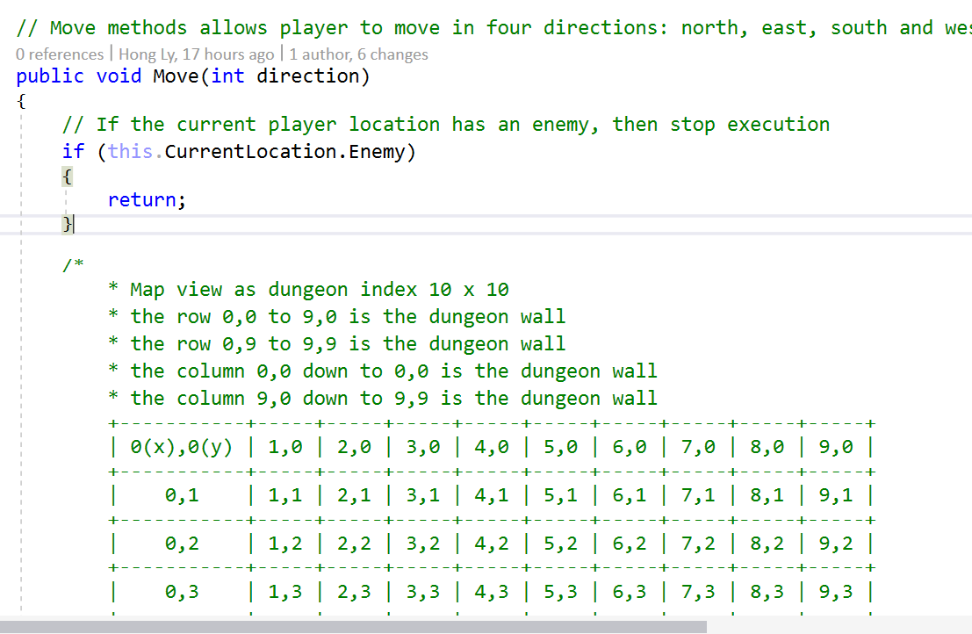

*Move method is used through Unity Inspector.*

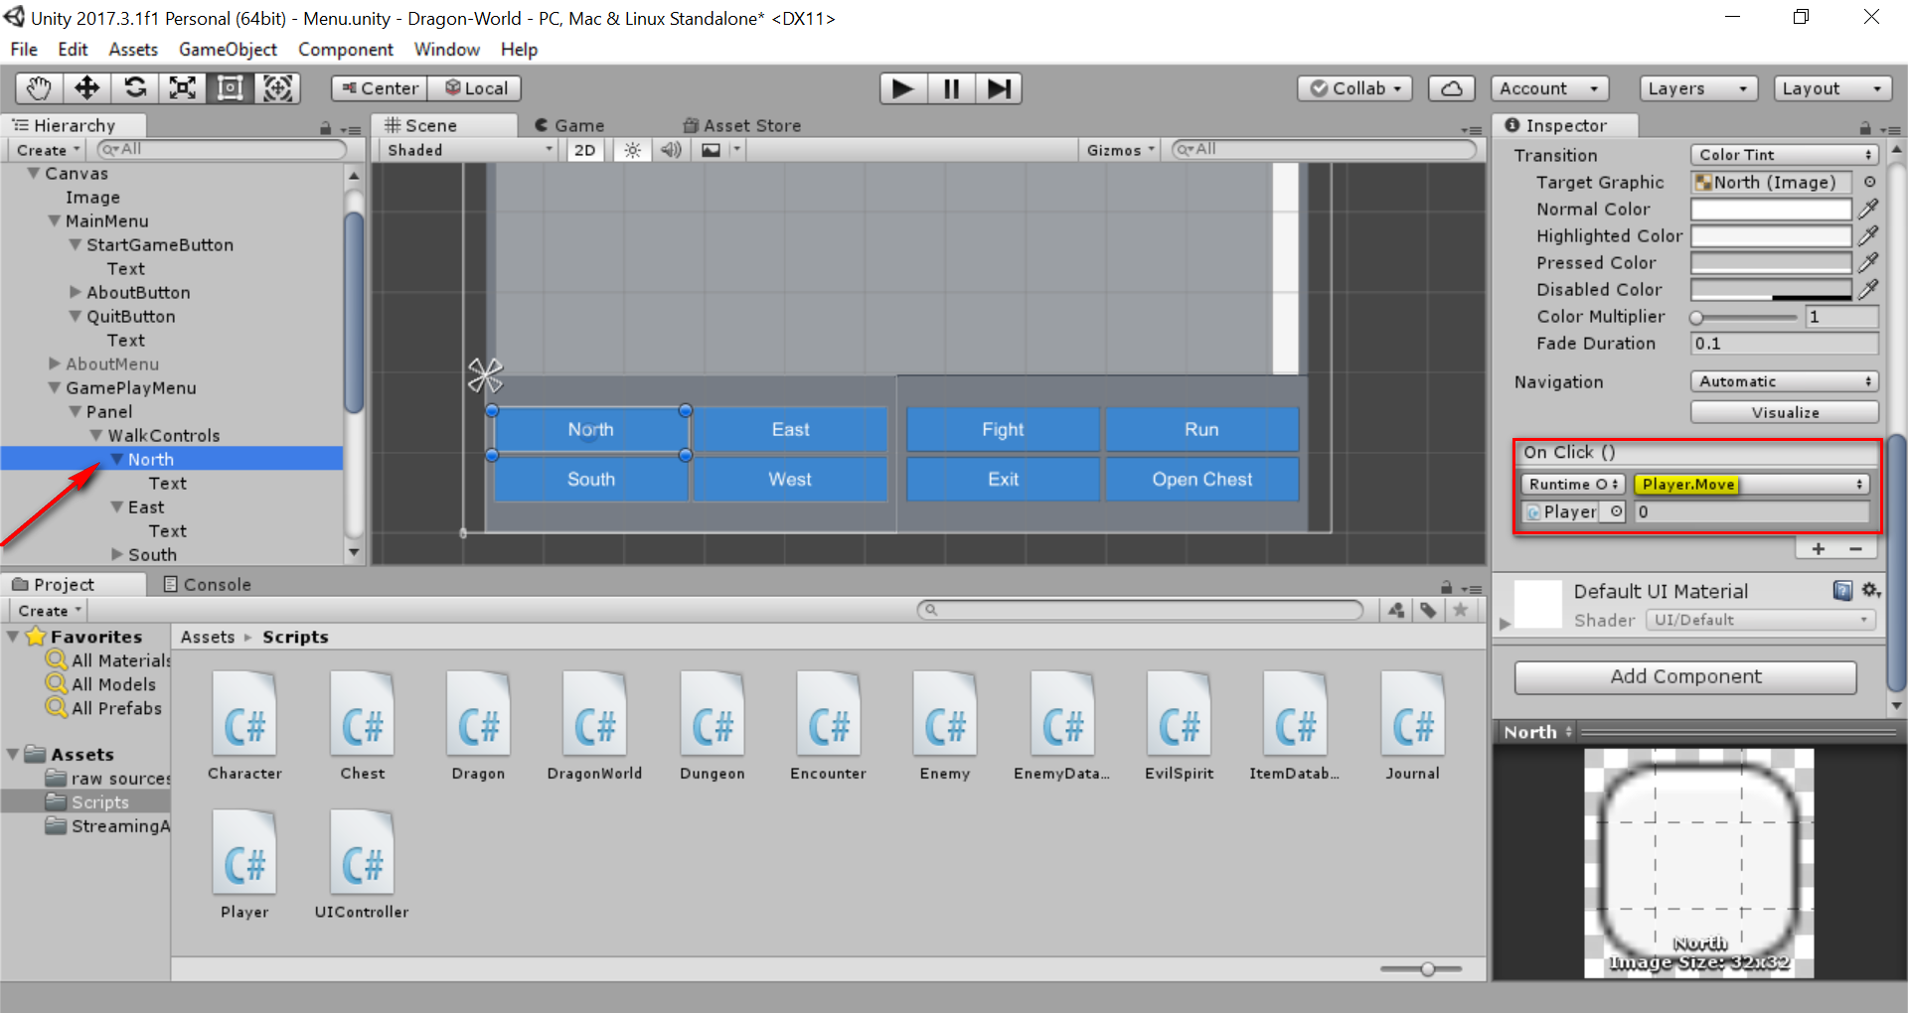

*Move method is used and assigned to walk controls with On Click event*

### **Criteria: Legal [D]**

☑ [Pass]

* Have a licenses.txt file, and all materials that are used have legal rights to use for commercial use.

**Evidence:**

<https://github.com/lyhd/Dragon-World/blob/master/licenses.txt>

☑ [Credit]

* Have a Legal section / About page with Legal section, where all attributions that are made are legally required to.

**Evidence:**

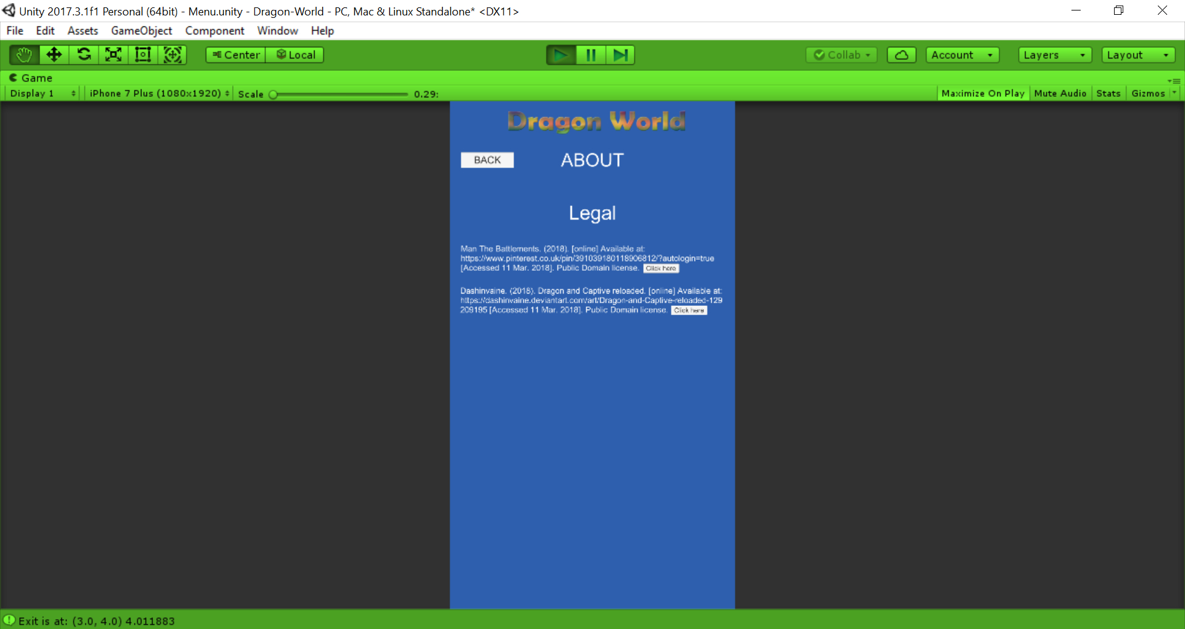

*Legal section under About page running on Unity*

☑ [Distinction]

* Item name: image, sound, method or class.
* License type: (Public Domain / CC-BY / CC0 / GPL / MIT / Apache / BSD).
* Author/attribution: author name.
* Attributions include hyperlinks to source pages.

**Evidence:**

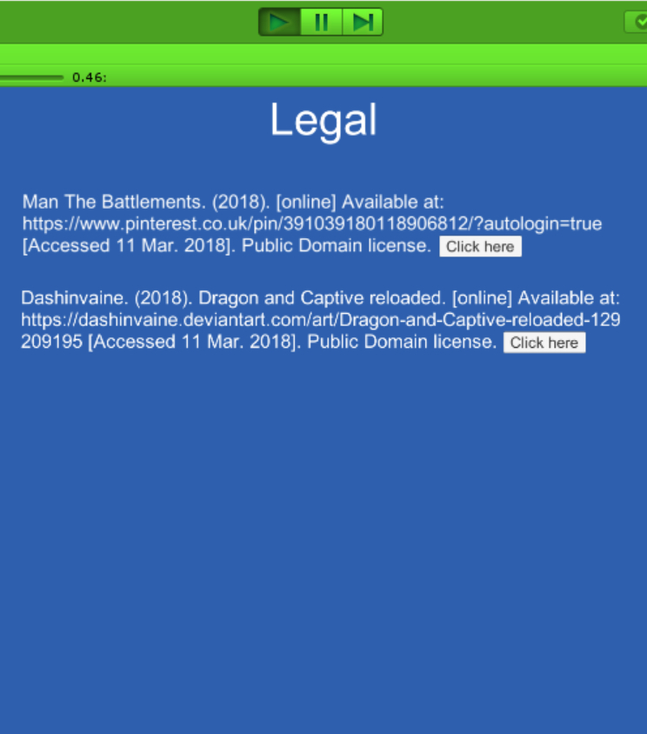

*Users can press on the “Click here” button to link to the source page*

### **Criteria: Playability [HD]**

☑ [Pass]

* Your game is engaging to play for at least 30 minutes.

**Evidence:**

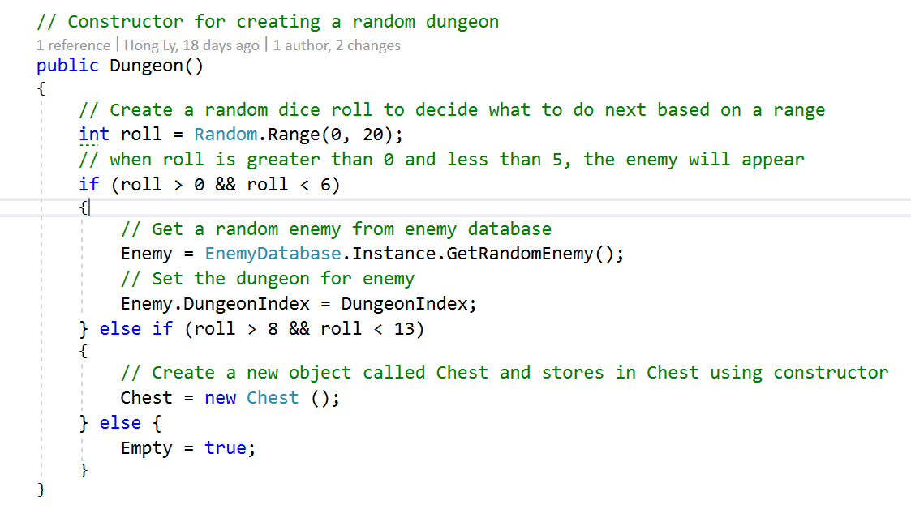

*Randomly get enemy for the dungeon*

☑ [Credit]

* Your game is engaging to play for at least 2 hours.

**Evidence:**

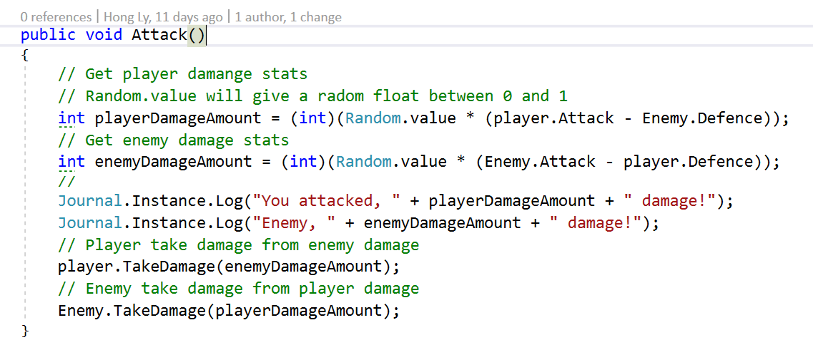

*Player can attack the enemy found in the dungeon*

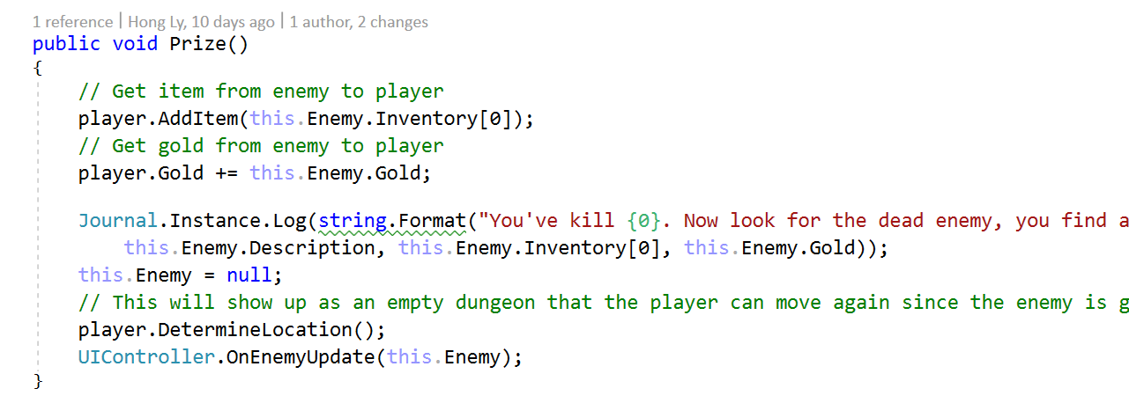

*Player can collect the prize once the enemy is killed*

☑ [Distinction]

* Your game is engaging to play for at least 5 hours.

**Evidence:**

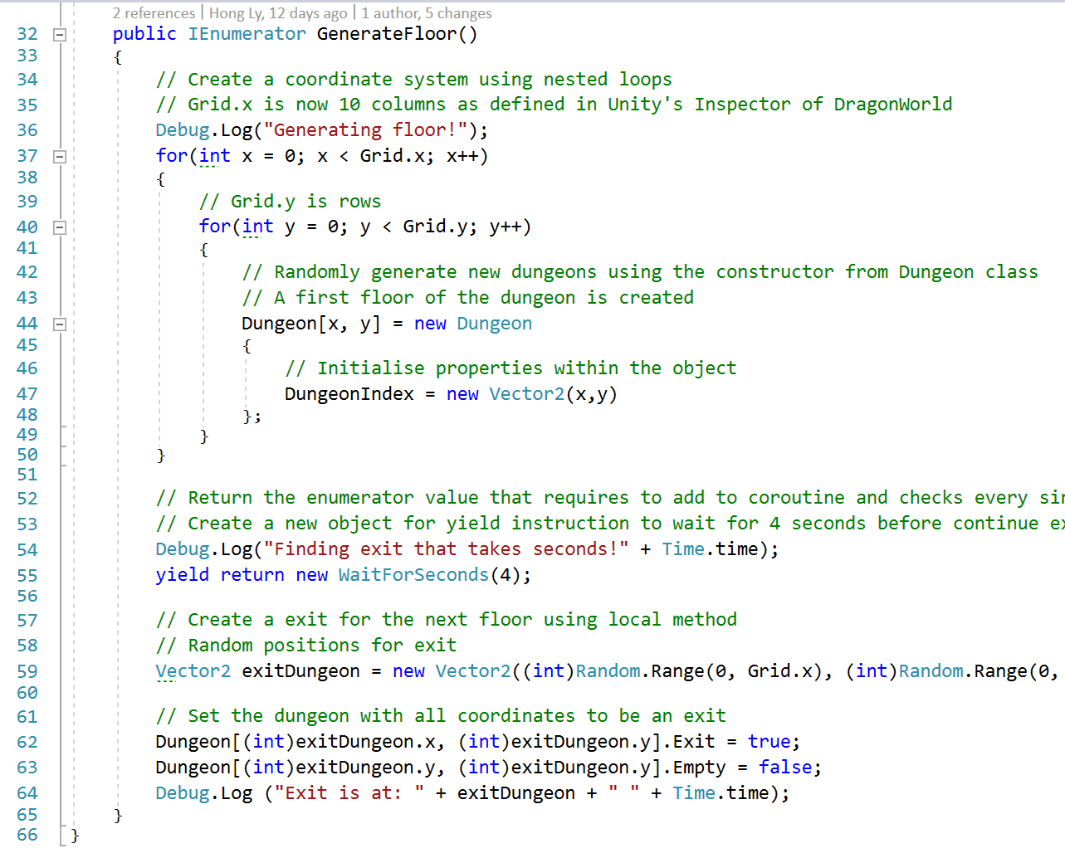

*New floors can be generated randomly to avoid repetition and player always experience new dungeons and floors.*

☑ [High Distinction]

* Your game is engaging to play for at least 10 hours.

**Evidence:**

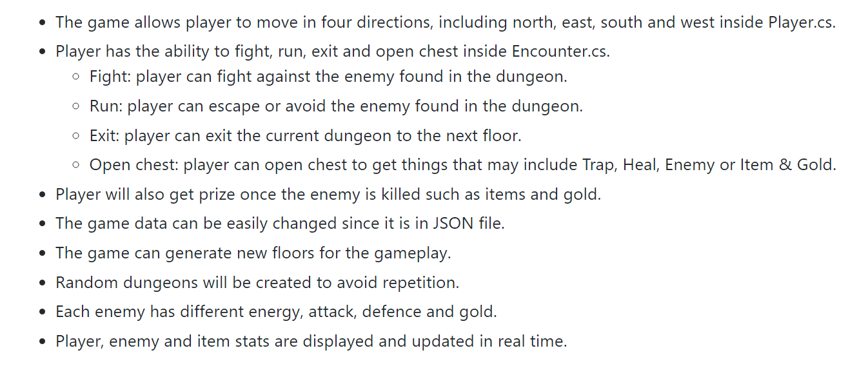

*There are many functions that player can experience within the game*

### **Criteria: Data Handling [HD]**

☑ [Pass]

* You load all your game data through local text files.

☑ [Credit]

* You also have all app constants in local text files.

☑ [Distinction]

* Load and save user settings to an external file or DB.

☑ [High Distinction]

* Load and save user state from/to external file or DB.
* Easy to create, edit and update.

**Evidence:**

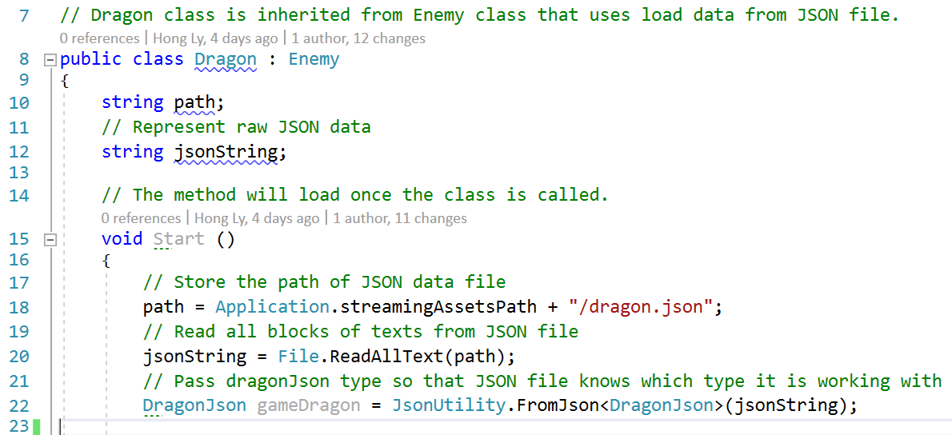

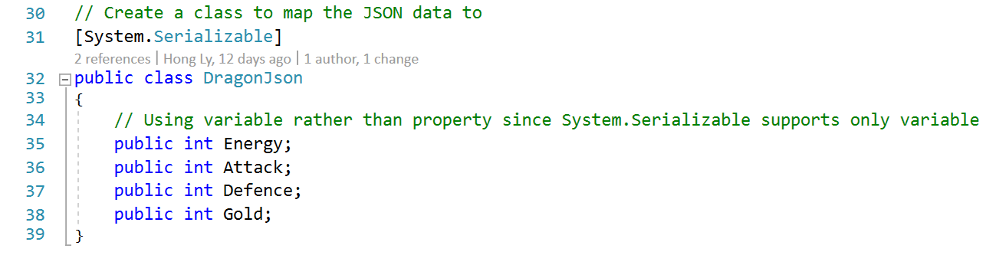

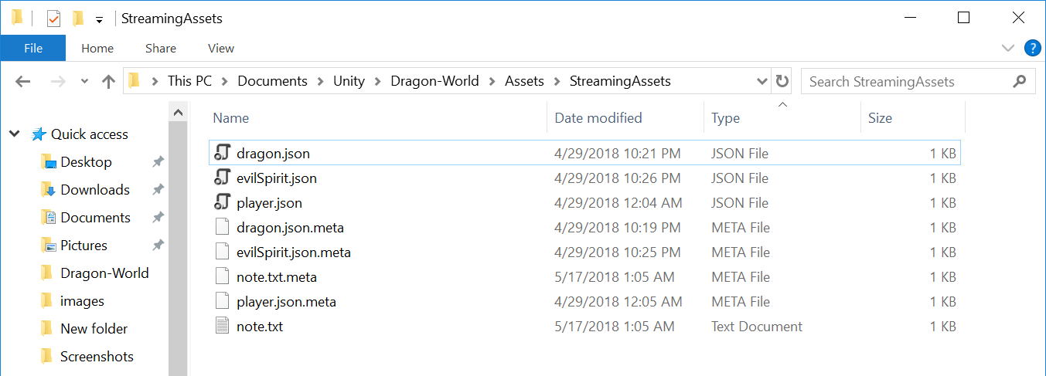

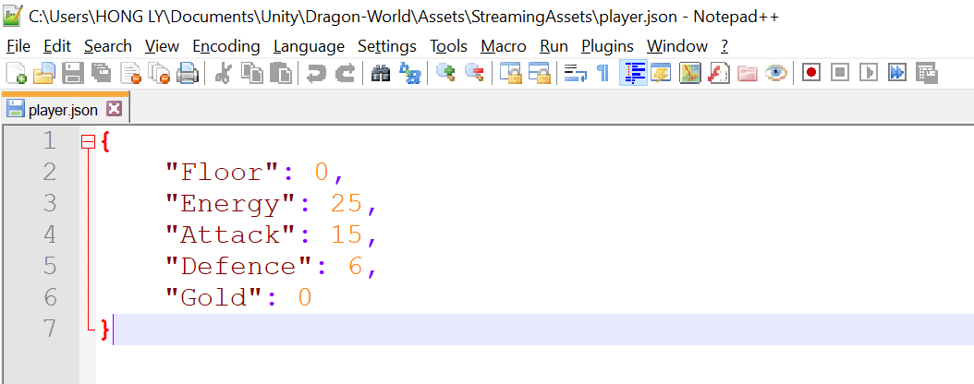

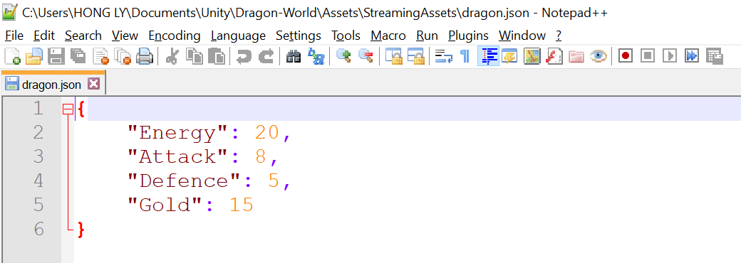

*Easy to create and update with JSON format*

### **Criteria: Layout [D]**

☑ [Pass]

* Your app works in portrait phone mode.

☑ [Credit]

* Your app works in both portrait phone, tablet portrait, and tablet landscape mode.

☑ [Distinction]

* Dynamically adjusts in real-time in orientation and resolution.

**Evidence:**

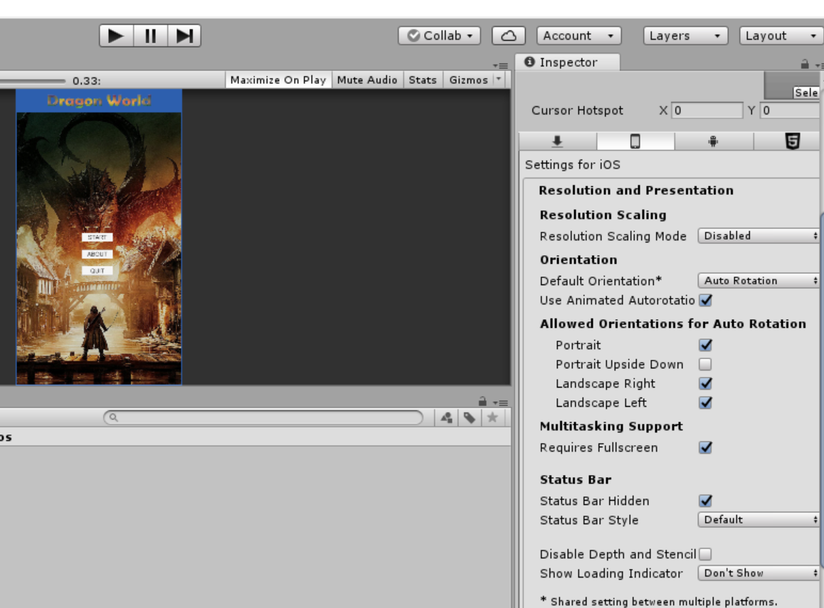

### 

Also included in README.md here: <https://github.com/lyhd/Dragon-World#dynamic-in-orientation-and-resolution-settings>

### **Criteria: Bugs [D]**

☑ [Pass]

* Code gracefully handles all bugs, and restarts or resumes as appropriate.

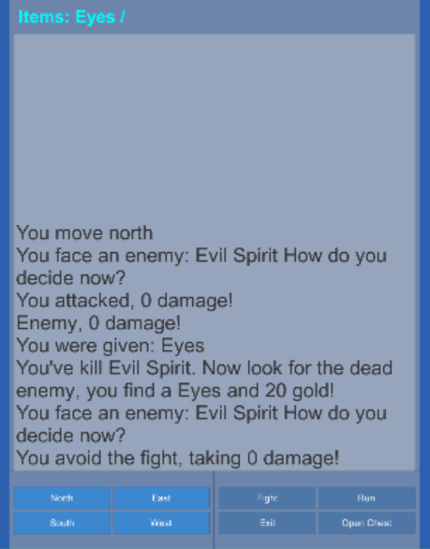

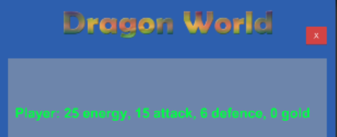

*Player can go back to the main menu by pressing on the red cross button and when player enters the gameplay, the play will resume.*

☑ [Credit]

* code also keeps all data safe and saved, as well as captures and details and reports bugs to the end user at a high level.

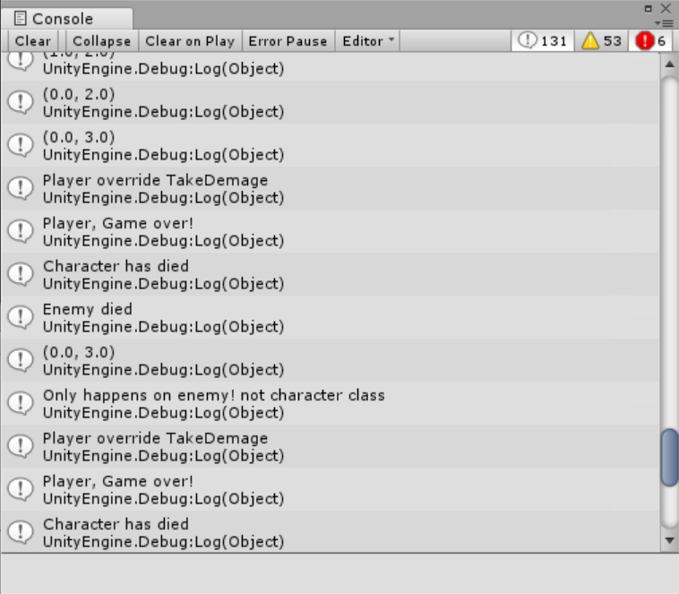

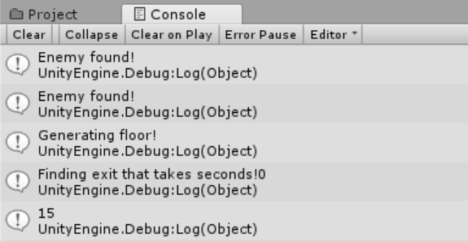 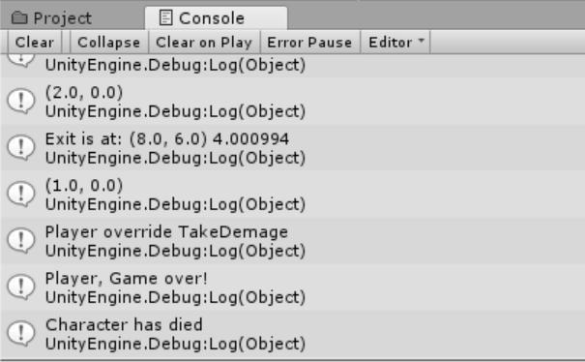

[Distinction]

* Your code also keeps a log page, that the end user can access, listing all bugs captured.

### **Criteria: Readme.md [HD]**

☑ [Pass]

* Includes your name, app title, app platform, link to GitHub, and an overview of your app.

**Evidence:**

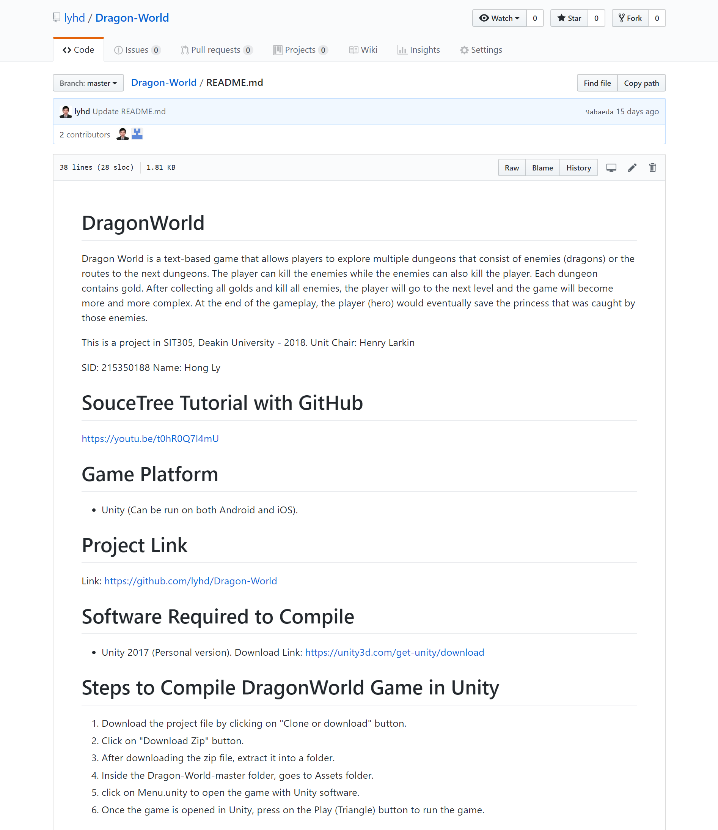

☑ [Credit]

* Includes an explanation of major features.

**Evidence:**

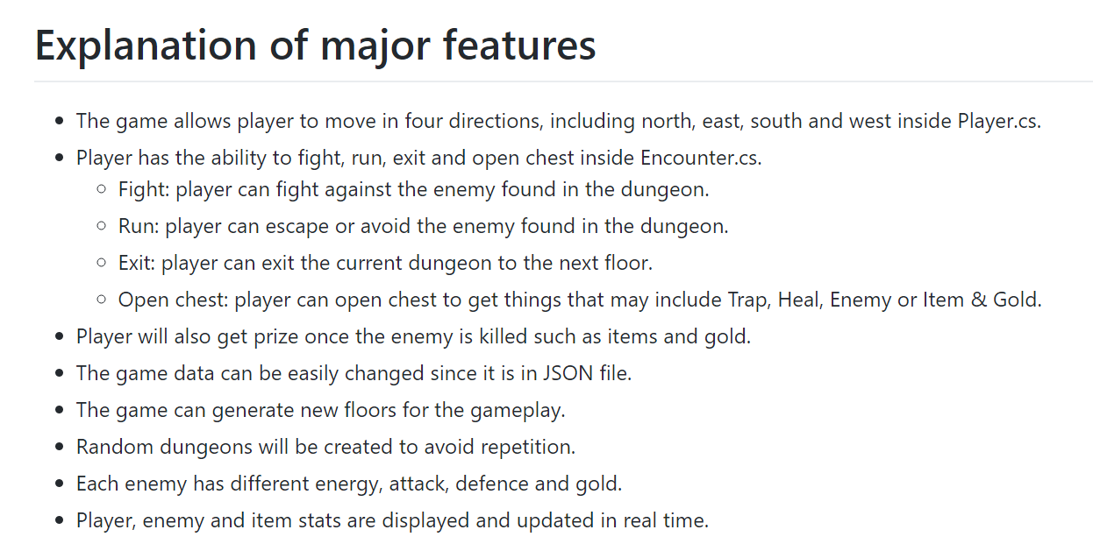

Link: <https://github.com/lyhd/Dragon-World#explanation-of-major-features>

☑ [High Distinction]

* Includes an API reference of major public classes and methods so that other developers can take over the project.

**Evidence:**

### 

Link: <https://github.com/lyhd/Dragon-World#api-reference-of-major-public-classes-and-methods>

More info about this project's API Reference can be found from the link below on page 29: <https://goo.gl/UwXFy6>

### **Criteria: Publishing [HD]**

☑ [Pass]

* Your app meets all App Store Guidelines.

**Evidence:**

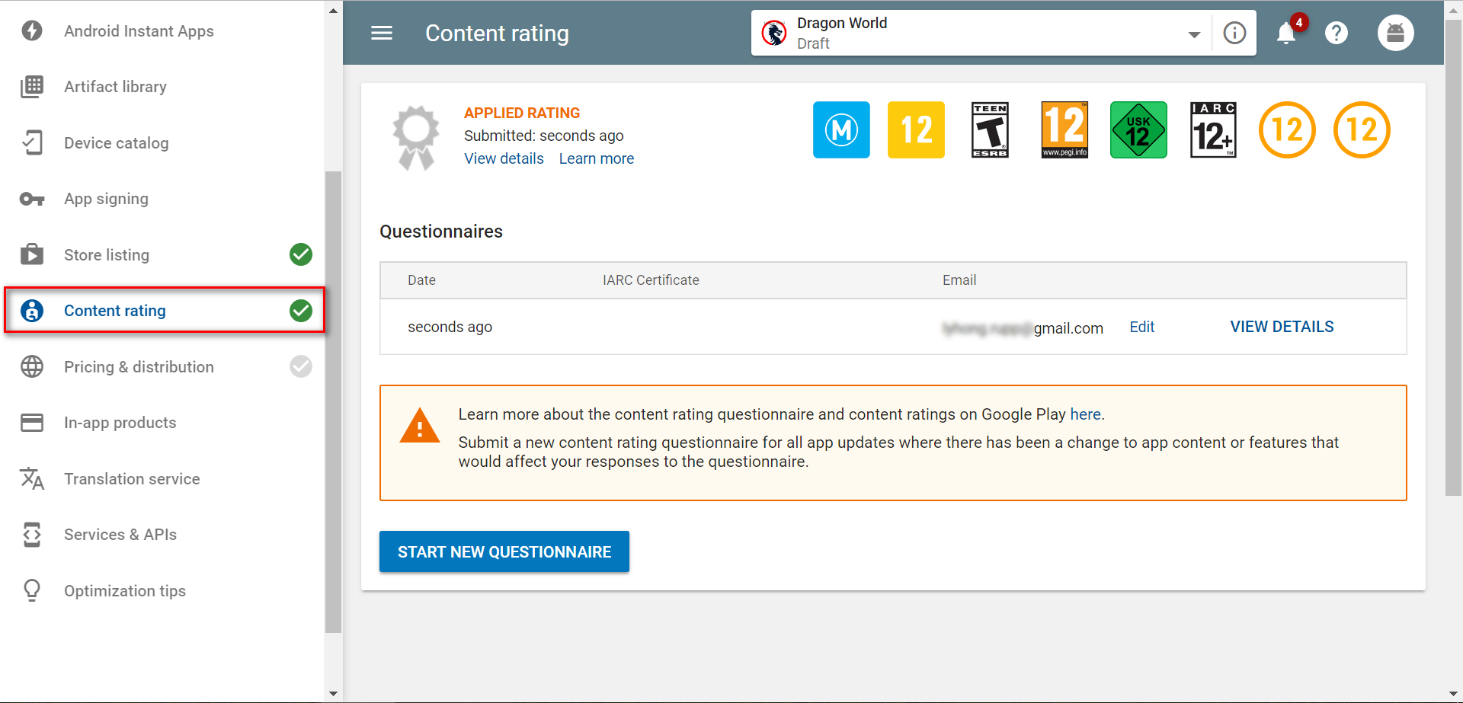

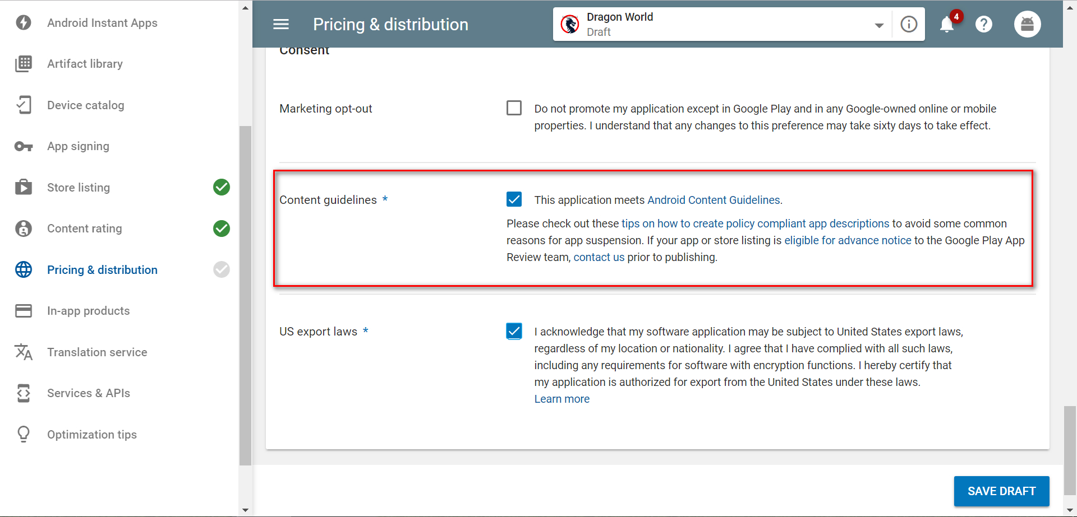

☑ [Credit]

* All icons and splash screens for the targeted devices.

**Evidence:**

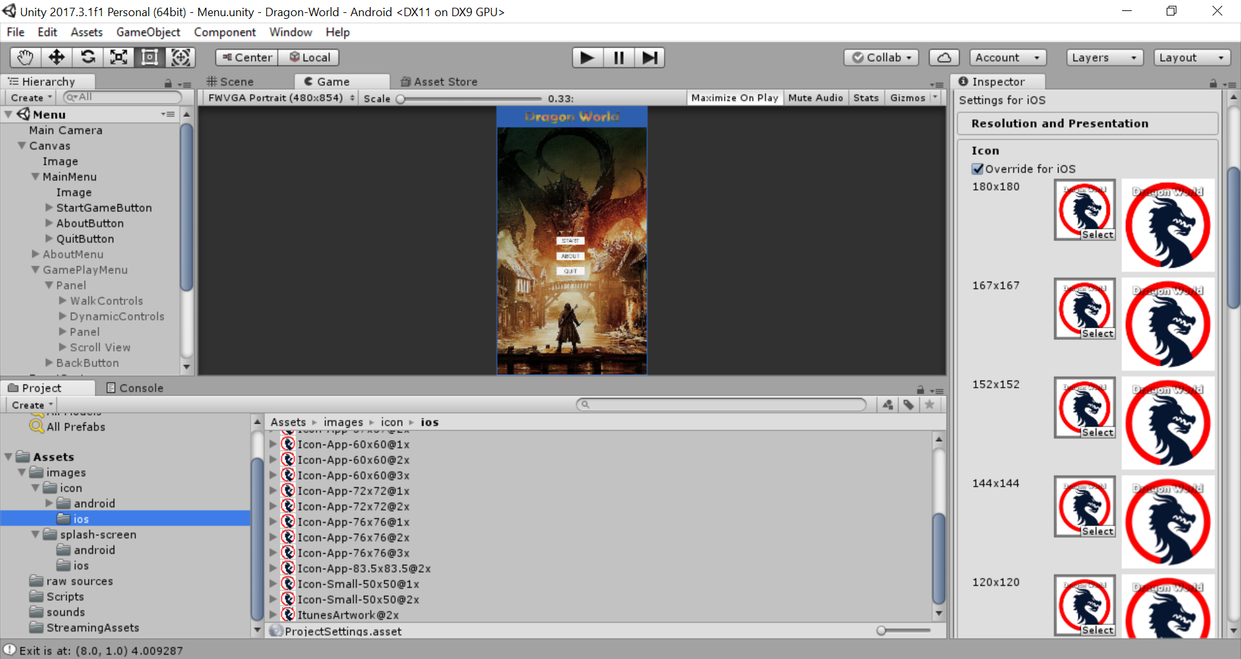

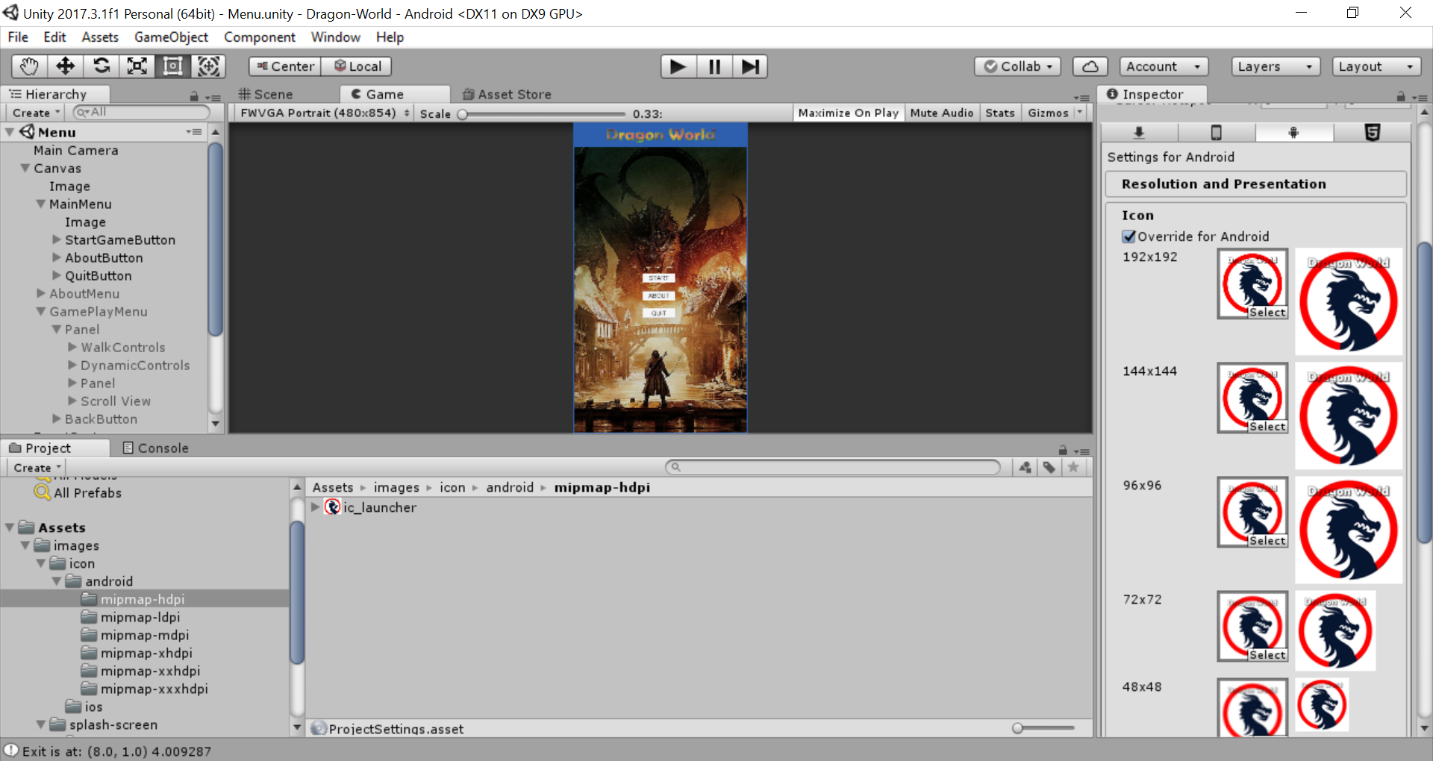

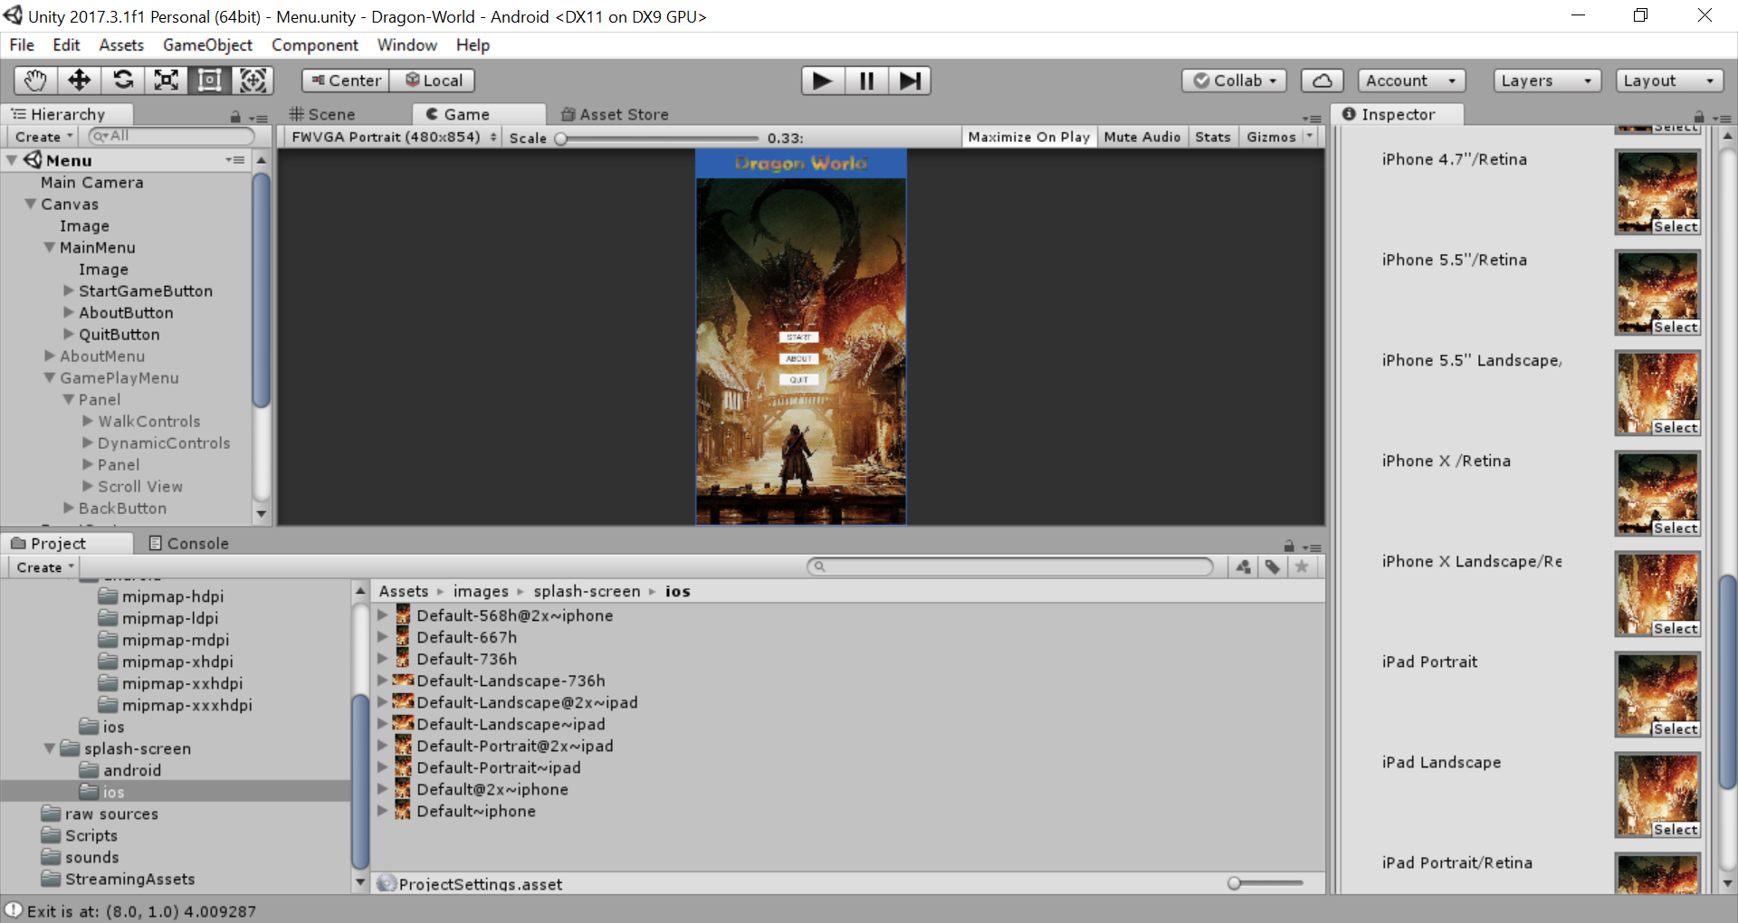

Also indicated here: <https://github.com/lyhd/Dragon-World#splash-screens-and-icons-settings-for-android-and-ios>

☑ [Distinction]

* The game has a folder of all required information to publish the app (promo text or screenshots per device).

**Evidence:**

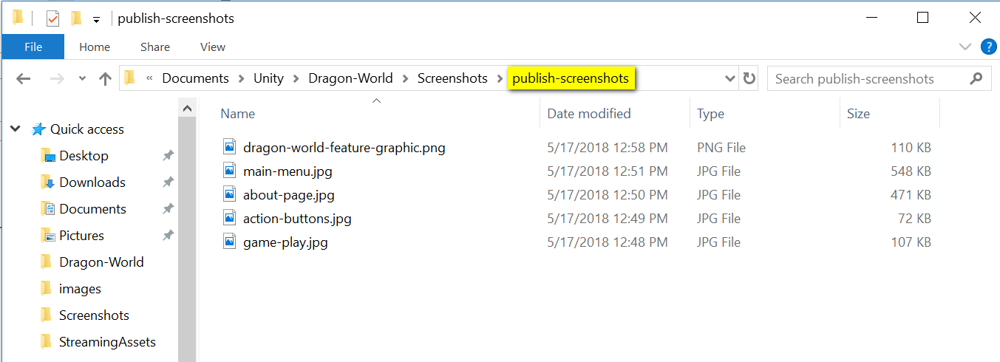

☑ [High Distinction]

* The game is published.

Since Apple App Store requires $99/year for publishing apps and game, I decided to publish the game to Google Play Store with a one-time fee of $25.

**Evidence:**

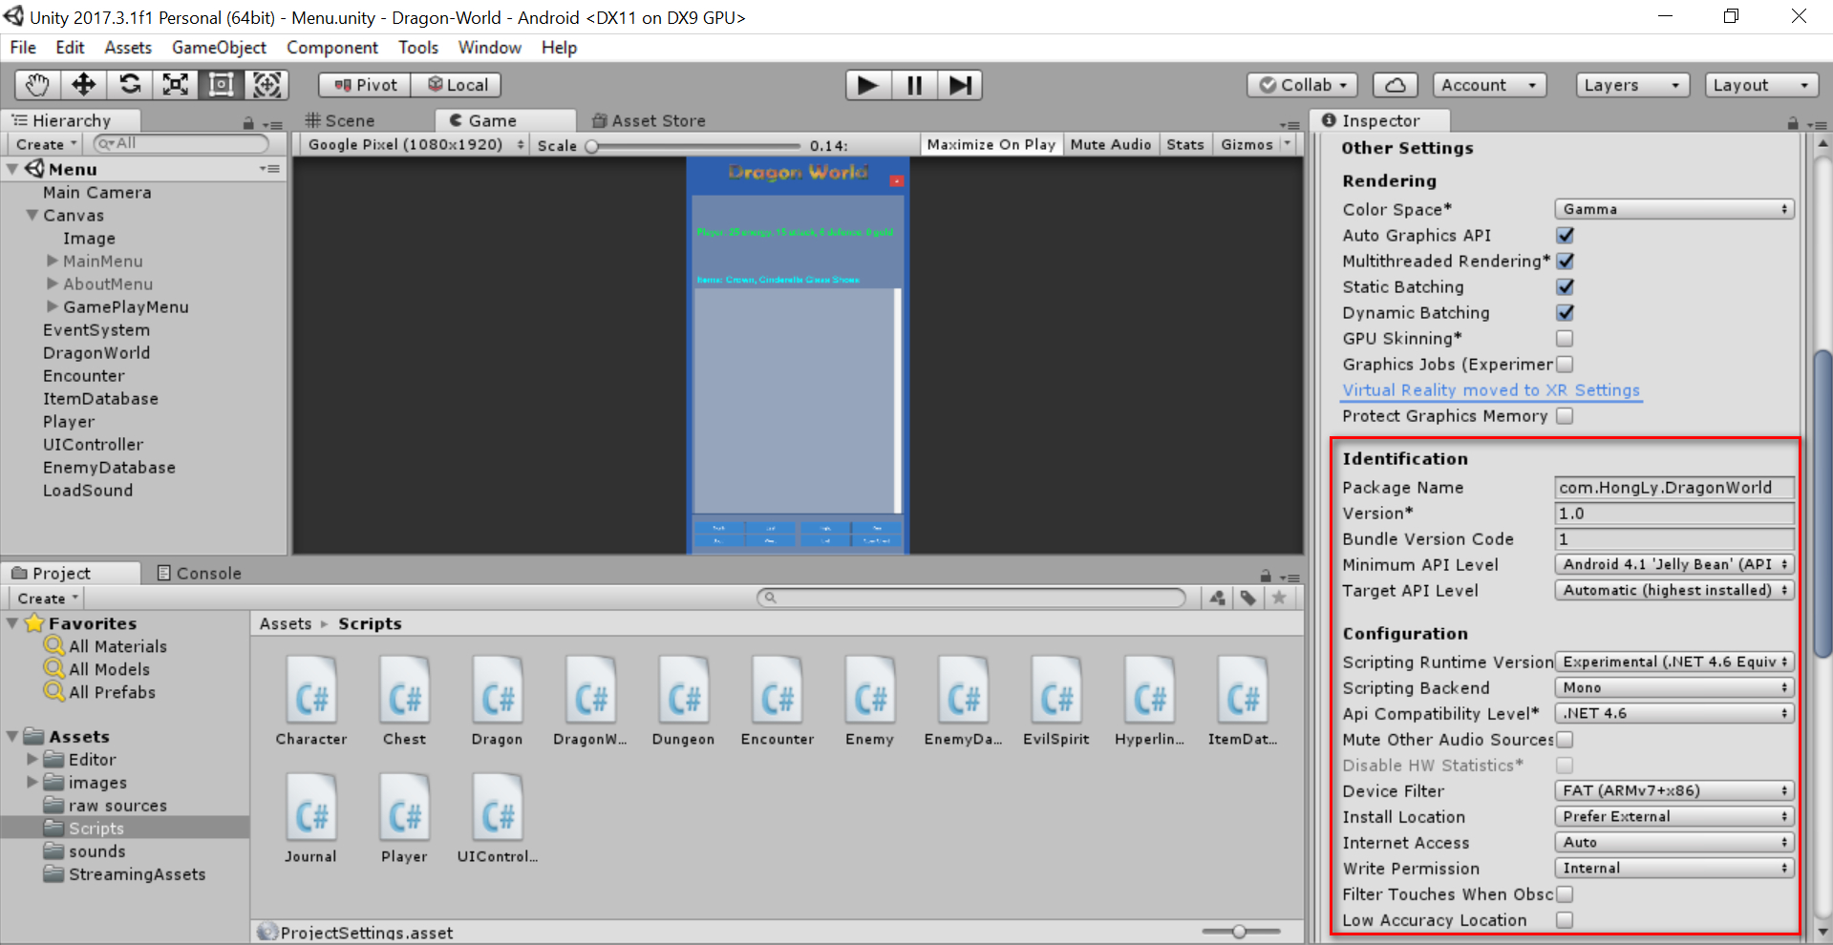

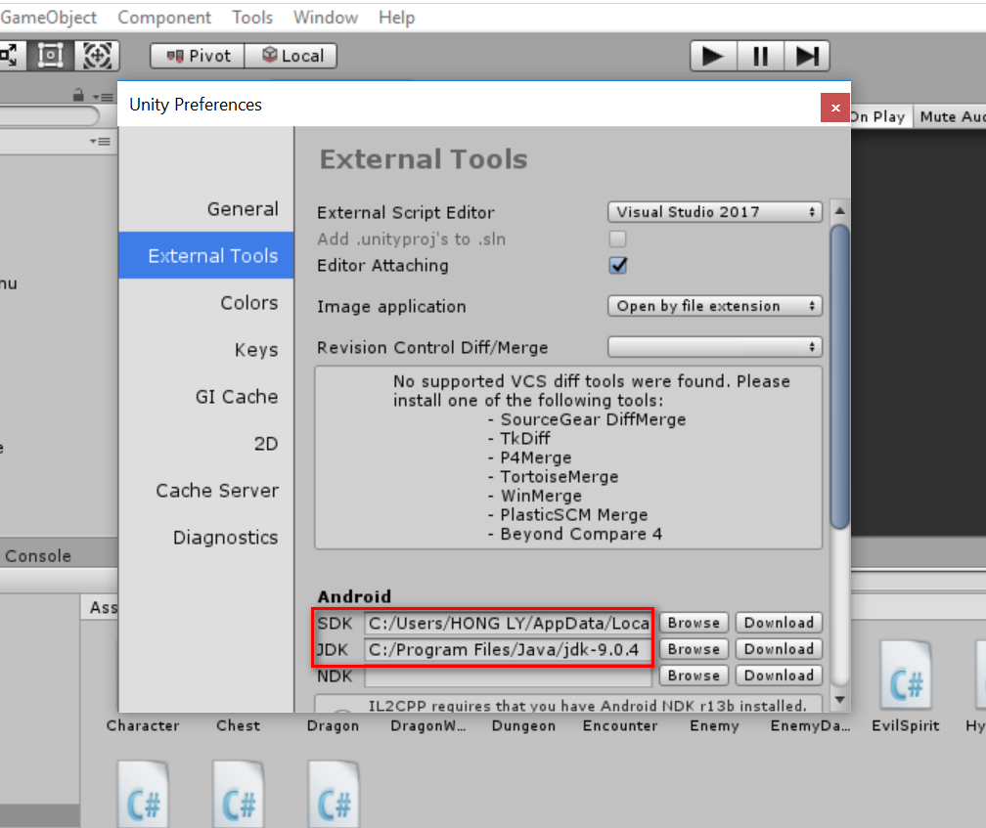

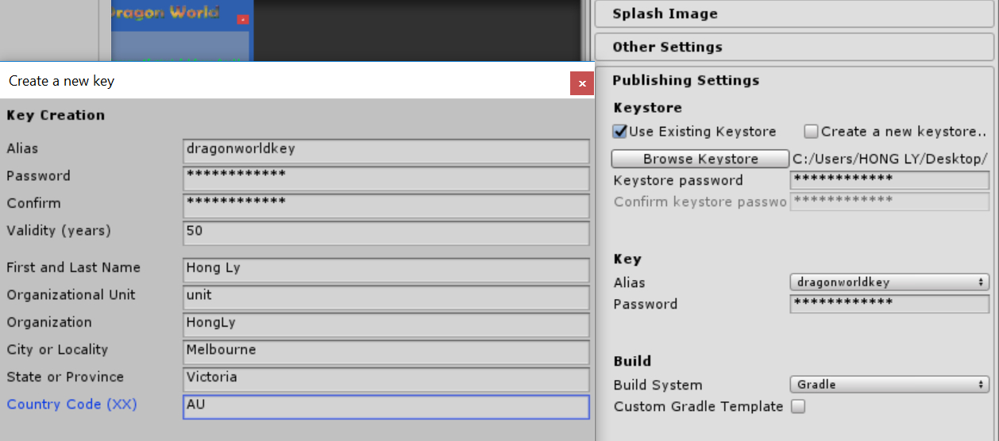

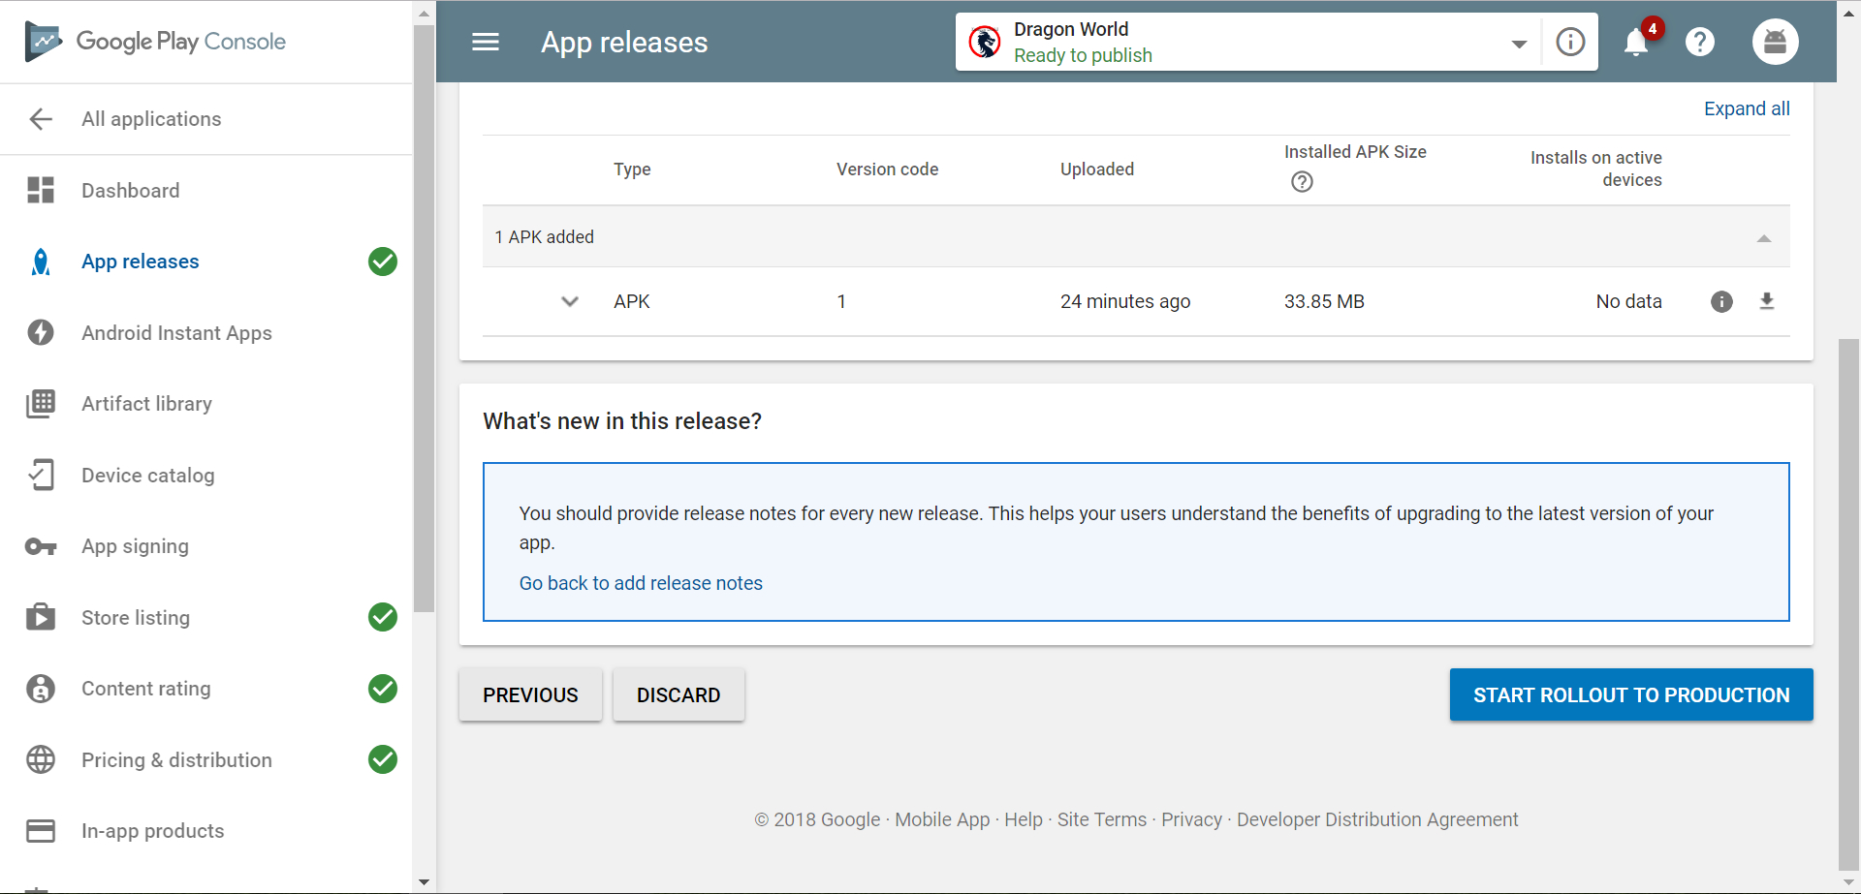

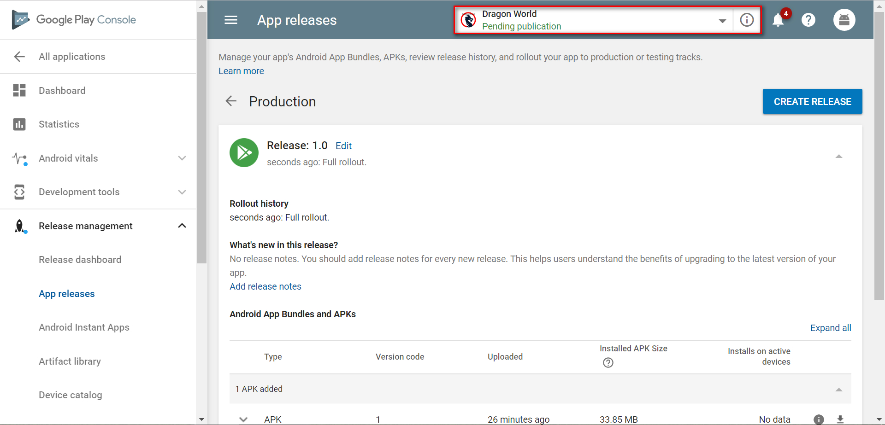

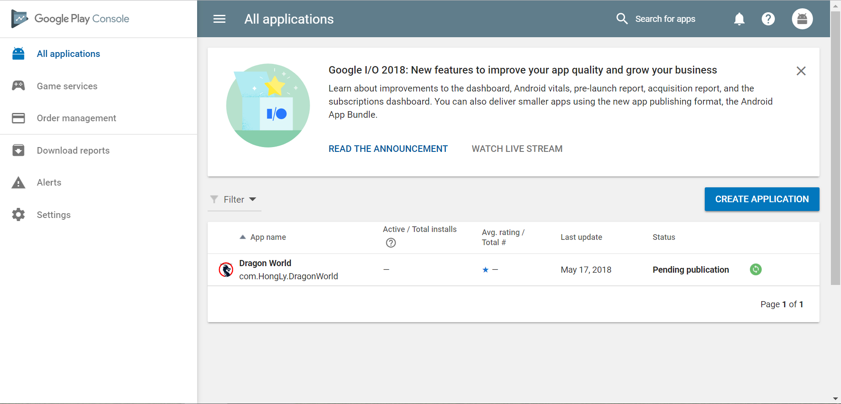

### **Criteria: Demonstration Video [D]**

☑ [Pass]

* Demonstrate all main features of the app that you wish to be graded for.

☑ [Credit]

* Video and audio are clear and easy to understand.

☑ [Distinction]

* Your video has a professional feel to it, to the level similar to company YouTube videos.

**Evidence:**

In the video, the included all main features of the game, video and audio are clear and easy to understand. The video has been carefully produced.

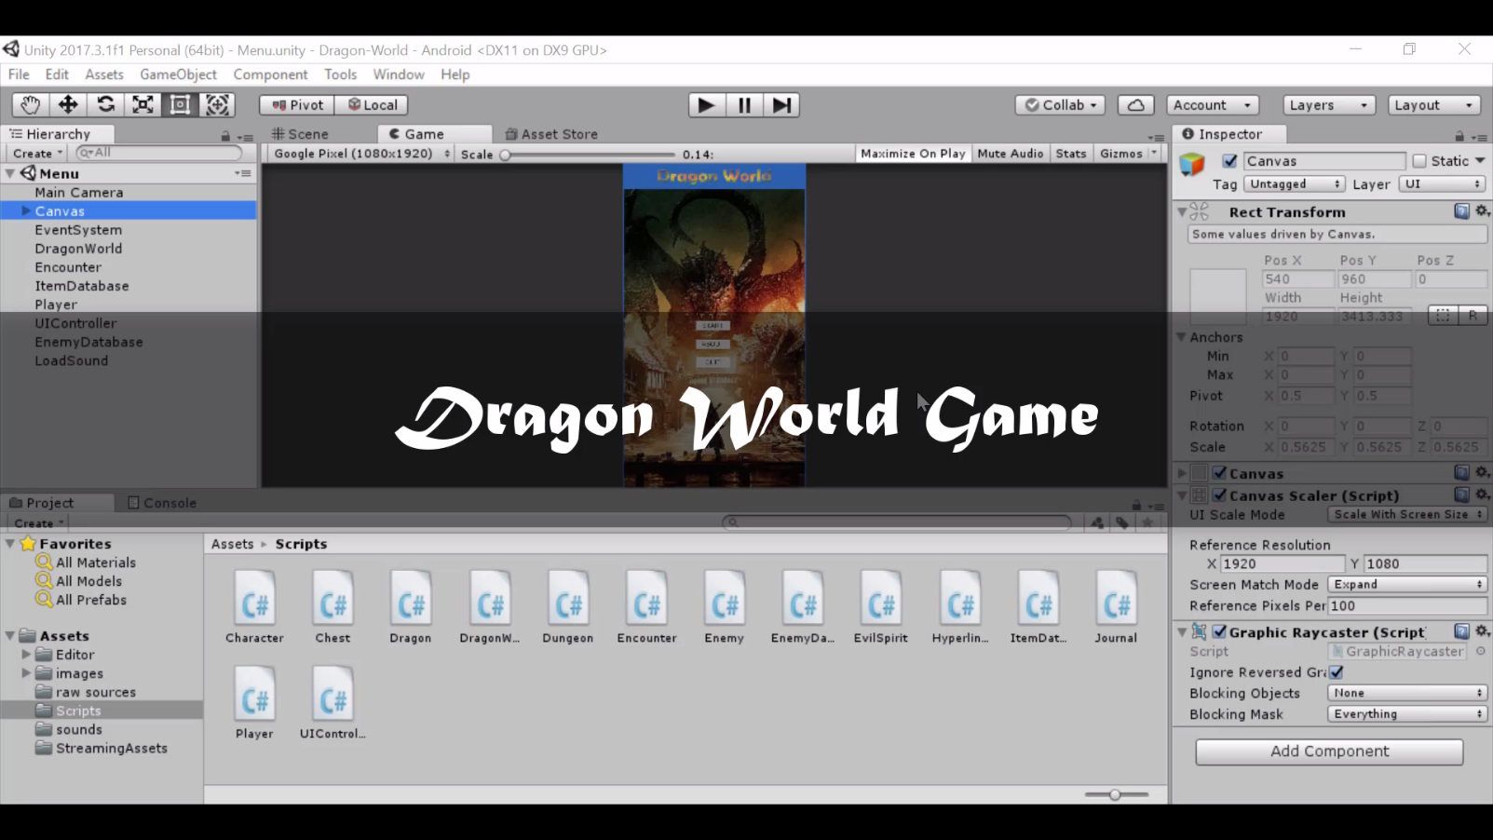

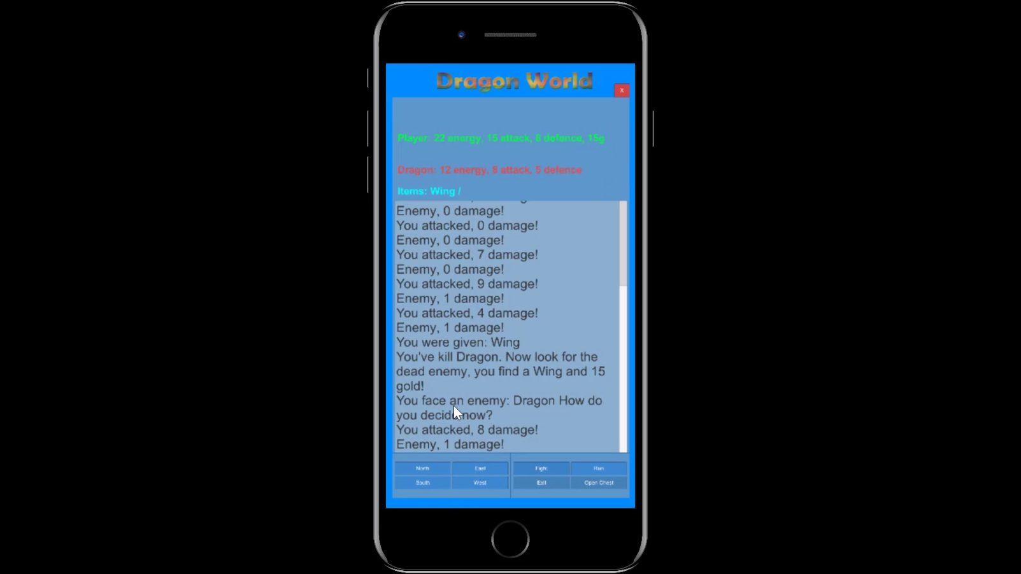

Here is the link to the video:

<https://youtu.be/Vycf8MM8Ix8>

* Note: There is no HD rubric for Weekly Progress, Code Quality, Legal, Layout, Bugs, and Demonstration Video.